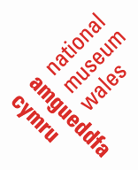
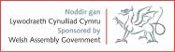

Spring Bulbs for Schools
Project Outline
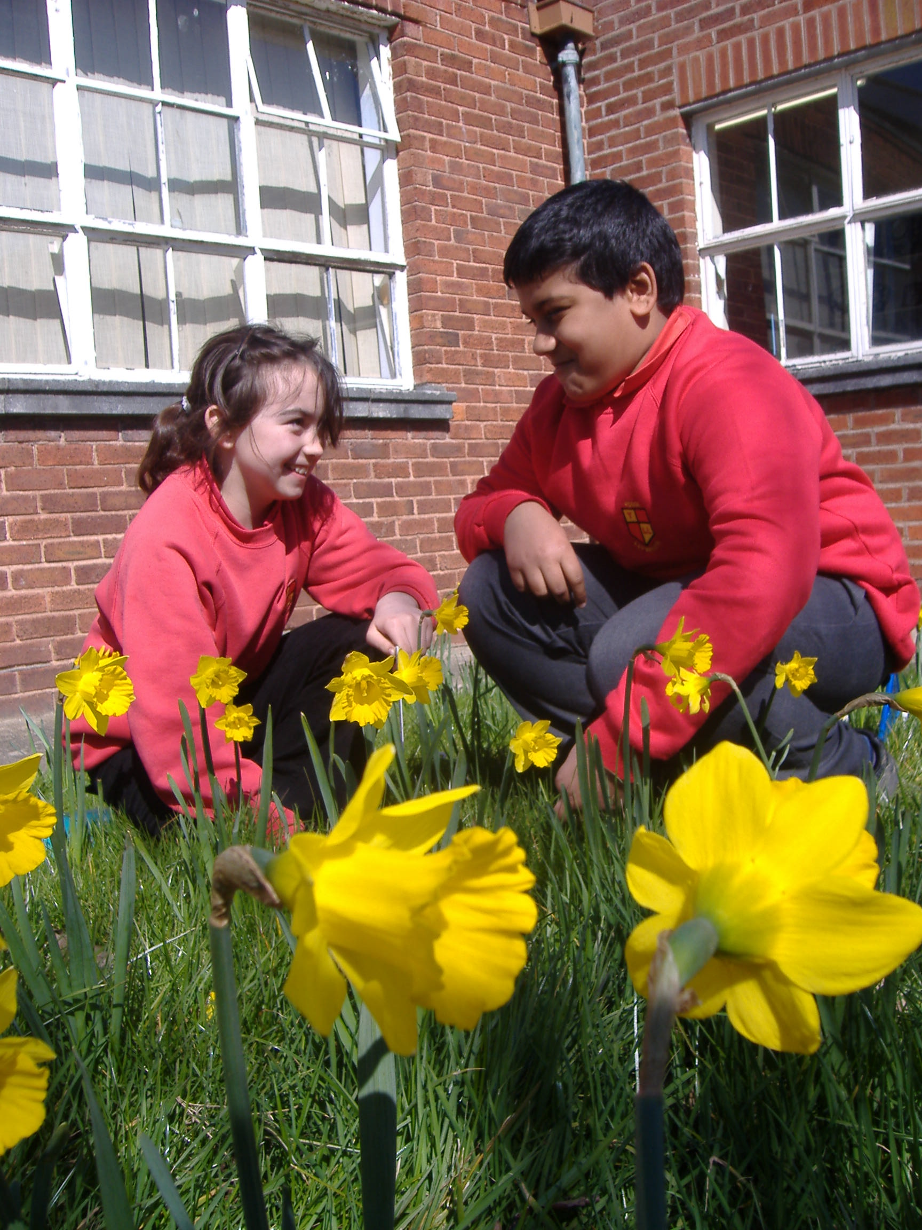
Get out of the classroom!
Join the 1000’s of pupils already taking part in this exciting environmental investigation.

Spring Bulbs for Schools provides primary school pupils with the opportunity to adopt study and record the development of spring bulbs as part of a National climate change study. Each pupil will receive a Tenby Daffodil and Crocus bulb to record growth and flowering times. Through collecting and comparing real data pupils discover how our changing climate is affecting our seasons and what this means for ourselves and the nature around us.

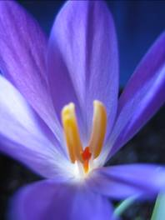

Suitable for: Year groups 4, 5 & 6.

Curriculum: All learning objectives are compatible
with the Science, Geography, Maths & ICT curriculum.

Timescale: September/October: Starter pack and the bulbs delivered to your school. October 20th: All schools to plant their bulbs and to begin keeping weather records. January, February and March: Observing flowering, recording and reporting results through the spring bulbs website. May: School and pupils to be awarded with Super Scientist Certificates.

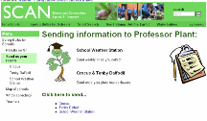
How do I take part?

Read through ‘Our pledge’ overleaf then fill in the application form. This project in on going and one year group from each school can take part each year.

To find out more visit www.museumwales.ac.uk/scan or call 02920 573304

Spring Bulbs for Schools

Feedback from teachers:


- Excellent resources and training. Pupils thoroughly enjoyed the project – they were really disappointed to finish.

- Excellent! Caring for and learning about the bulbs was a source of wonderment! We drew graphs of temperature and rainfall which was great practice for maths and science.

- The discussions raised about the influences of an ever-changing climate were the most valuable elements of the project.

- The children really enjoyed taking ownership of the bulbs. Children of all abilities loved going out to record the weather and feeding the developments back to the class.

Feedback from pupils:

- I learnt that looking after a plant everyday is fun.

- I loved it! I learnt our climate is changing.

- I learnt about global warming and that different plants come out at different times.

- I learnt that bulbs store food for the next year and that a crocus closes its flowers at night.

Our pledge

We promise:
- To provide each pupil with the bulbs, pots and knowledge to take part in real environmental science project. By providing practical opportunities and resources to:

  - Plan, handle and communicate scientific information.
  - Study plant growth, reproduction and nutrition.
  - Study environmental change and understand the individual’s responsibility for the environment.

- To report and summarise the results of the investigation and reward each participating pupil and school with a Super Scientist Certificate.

If you agree:

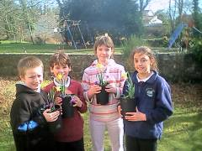
Pupils with their 1st flowers of the year.
- To ensure that each pupil adopts studies and reports the growth of their spring bulb (throughout Jan, Feb & March) and that the class as a whole keeps simple weather records (throughout October – March).

- To dedicate an area within your school grounds for placing thirty (2 litre) plant pots and to provide each pupil with 2 litres of compost or soil for planting.

Spring Bulbs for Schools - Application form

Class teacher: ________________________________________________________

School: ________________________________________________________________

Address:________________________________________________________________

______________________________________________________________________

______________________________________________________________________

Postcode: _________________________________________

Tel: ______________________________________________

E-mail: ____________________________________________

- We will require enough bulbs and pots for __________ pupils.

- Which year group will be taking part in the project this year? _____________

- E-mail and internet access at our school is: not possible /poor / Good / Excellent

- I have read ‘our pledge’ and understand the commitments involved in the project.

- We will require resources in the Welsh language.

- This is the _________ year our school has taken part in the project.

- This is the _________ year I am taking part in the project.

All bulbs & resources will be delivered to your school will by the 10th of October 2011.

Post to: Danielle Cowell, Education Department, Amgueddfa Cymru - National Museum Wales, Cardiff. CF10 3NP.

E-mail to: scan@museumwales.ac.uk

All forms must be received by the 31st of July 2011

