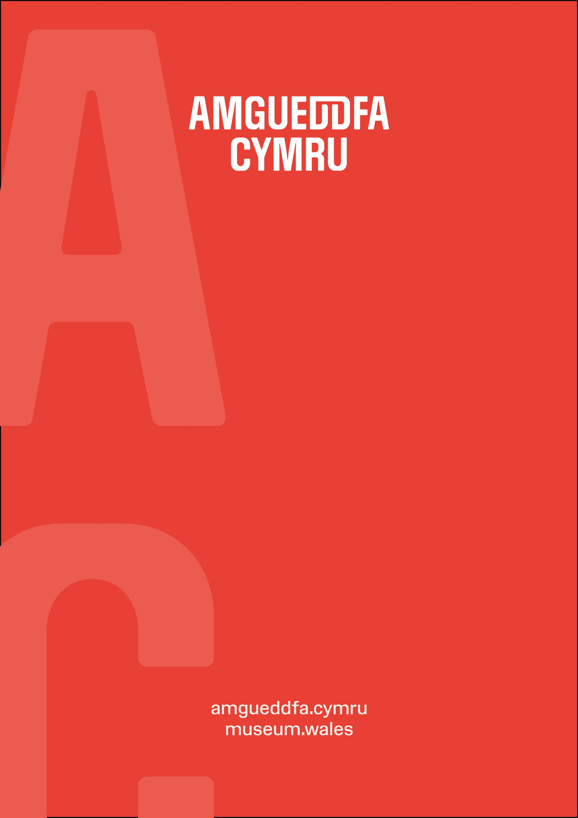

Well-being Statement 2030

Mae’r ddogfen hon ar gael yn Gymraeg / This document is also available in Welsh.

This document outlines Amgueddfa Cymru-Museum Wales’ Well-being Objectives, and how they will enable us to contribute to the achievement of the Well-being Goals as set out in the Well-being of Future Generations (Wales) Act.
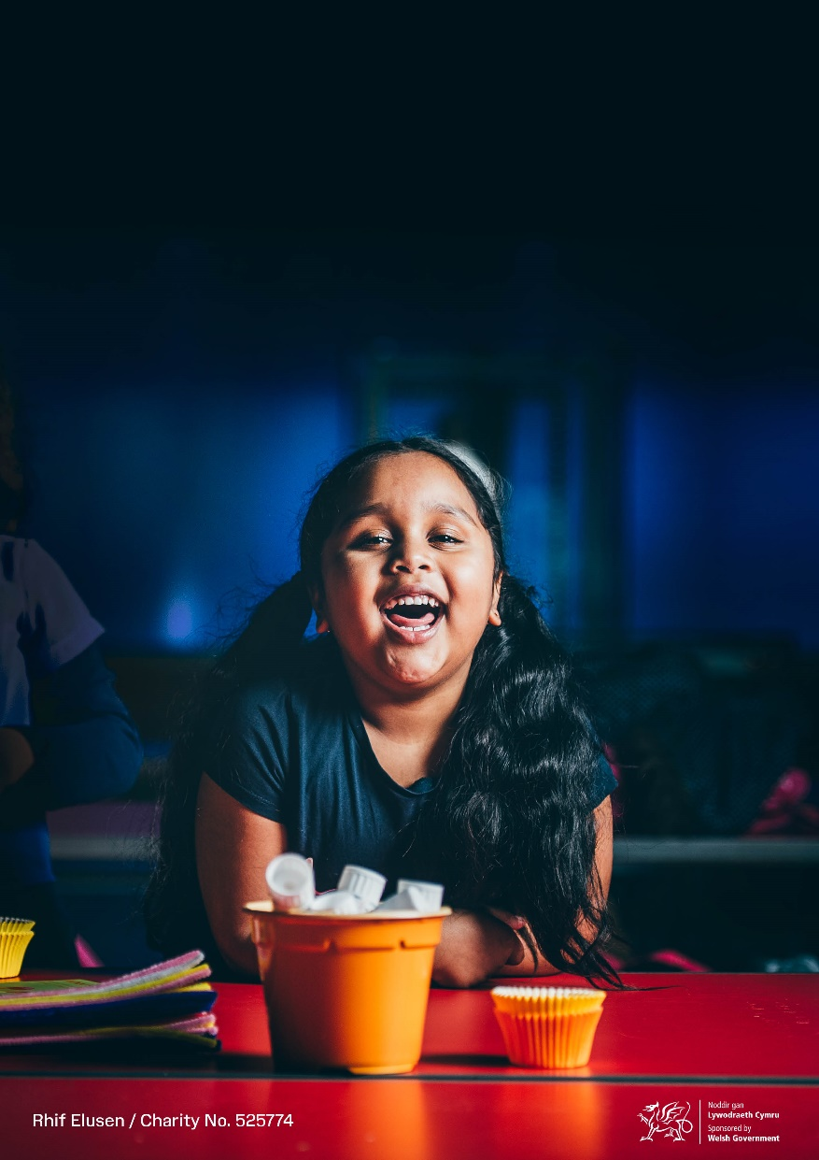
Our corporate planning documents embed the Well-being Objectives and ways of working and demonstrate how we intend to meet and report on their progress.

Amgueddfa Cymru

Amgueddfa Cymru is a charity, and a family of seven national museums and one collections centre located across Wales. Our welcome is free, thanks to funding from the Welsh Government and extends to people from all communities.

But we’re more than our buildings. Our sites are vital community spaces that reach far beyond their location on a map, website and digital platform.
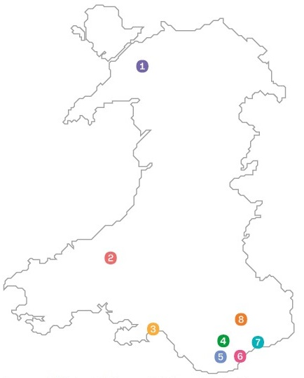

- National Slate Museum
- National Wool Museum
- National Waterfront Museum
- National Collections Centre
- St Fagans National Museum of History
- National Museum Cardiff
- National Roman Legion Museum
- Big Pit National Coal Museum

The Well-being of Future Generations (Wales) Act 2015
The Well-being of Future Generations (Wales) Act (referred to as ‘the Act’) is about improving the social, economic, environmental and cultural well-being of Wales.
The Act is in place to ensure that future generations have at least the same quality of life as we do now. The act provides for better decision-making by ensuring that public bodies take account of the long-term, help to prevent problems occurring or getting worse, take an integrated approach, take a collaborative approach, and consider and involve people of all ages and diversity.
The Act puts in place seven well-being goals. This statement sets out how we will contribute to them, responding to the duties on Welsh Government Sponsored Bodies named in the Act.

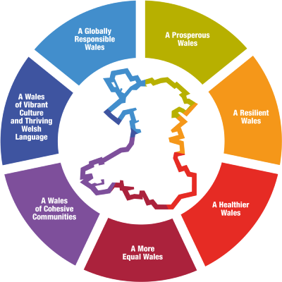

The Well-being Goals
- A prosperous Wales
- A resilient Wales
- A healthier Wales
- A more equal Wales
- A Wales of more cohesive communities
- A Wales of vibrant culture and thriving Welsh language
- A globally responsible Wales

5 Ways of Working
The Act also requires us to work in a sustainable way through 5 ways of working:
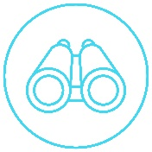Long-term
Taking an Integrated Approach
Involving People
Collaborating
Prevention

Inspiring People, Changing Lives
Our Vision, Inspiring People, Changing Lives, was developed within the framework of the emerging Well-being of Future Generations (Wales) Act 2015, and is well-aligned to the well-being goals set out in the Act.
The Act helped shape the development of our Strategy 2030. Our Strategy embodies the Act and is embedded through all our work.
Strategy 2030 was developed through involving staff and volunteers, stakeholders and partners, and people across Wales in consultation and engagement.
It consists of six Commitments and nine Enablers until 2030, which show how we’ll work with people and communities across Wales, through collections, public programmes and partnerships, to:

- Make sure that everyone is represented.
- Inspire creativity and learning for life.
- Help protect and restore nature and our environment.
- Support well-being through inspirational spaces and experiences.
- Discover and explore the museum digitally.
- Build global connections.

Strategy 2030

Strategy 2030 builds upon our Vision with a series of Commitments, Enablers and high-level Outcomes. Together these form our Well-being Objectives. They show where we can make the most significant difference to the people of Wales over the decade ahead.
Our well-being objectives were developed to help demonstrate our progress towards Strategy 2030 and the Act. They are embedded within our planning framework, through our 5-year Business Plan and our Annual Operational Plans. They are measured and reported on through our quarterly and annual reporting processes.
Our well-being objectives are further supported by the 5 Ways of working.
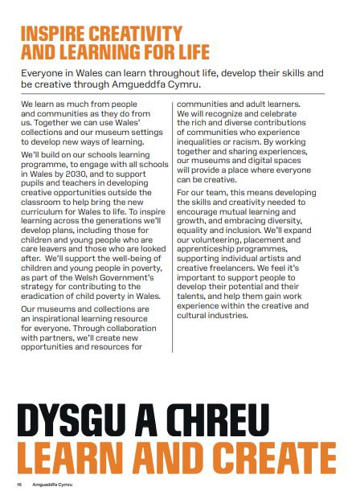
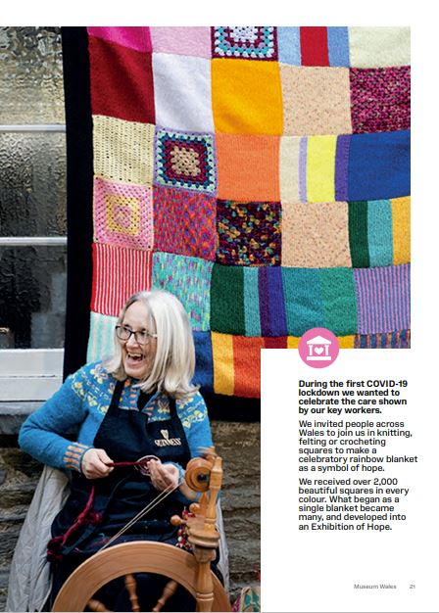
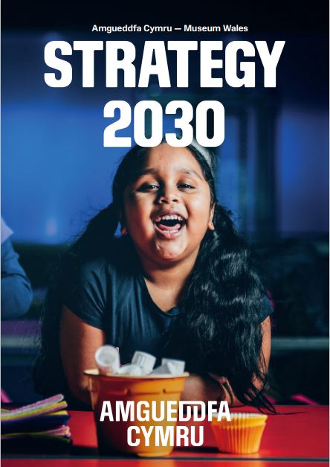

Developing our Well-being Objectives

In 2020 we carried out our most extensive consultation to date to develop Strategy 2030. This was part of our commitment to transforming the museum and embedding the Well-being Goals and ways of working from the Act.
We asked our staff, volunteers, people and partners (those who currently work with us, and those that don’t) what our plans should be for the next ten years. We used Future Trends and the Act to help develop our long-term Commitments and to help shape the development of the Strategy.
We discussed the plans with partners, key stakeholders and Welsh Government to ensure our plans were robust and fit for the future. We also collaborated with the Arts Council of Wales to undertake a series of in-depth research conversations with communities we consistently fail to engage with in our work.
This process was integrated into the development of our well-being objectives. We used the three-horizons model to identify risks and opportunities and help us plan better for the long-term.
Involving people in the development of our plans gave us the chance to discuss and reflect; and the opportunity to build a Strategy that meets the needs of people across Wales.
Our Well-being Objectives
We have mapped the Well-being of Future Generations (Wales) Act 2015 against our Well-being Objectives (Commitments and Outcomes). The following sections provide further details.


We are taking an integrated approach to delivering against the Well-being goals which means that most of our well-being objectives contribute to the delivery of multiple goals.


We are collaborating with many partners on plans, projects, events and exhibitions across Wales. Working in this way helps us to support the shared delivery of objectives and understand the pressures and challenges that we and other organisations may face, to help prevent problems from occurring or getting worse.

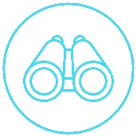
We are involving staff, volunteers, individuals and communities in the development and delivery of our programmes and plans, ensuring that they are supported and represent people across Wales.

Our Commitments and Outcomes are long-term, however our annual and 5-year corporate planning helps us to work towards meeting these long-term needs. This is supported by our governance structures which enable effective planning and decision-making.

For everyone
We have developed a number of Well-being Objectives to ensure we deliver on our Commitment to Make sure that everyone is represented, and with Arts Council of Wales have jointly developed a Widening Engagement Action Plan (2022-25).
We’ll work to make sure that:
- The national collection represents and is shared with all of the people of Wales.
- We play a leadership role in supporting the Welsh Government's Cultural Strategy.
- Exhibitions and events are created, used and enjoyed with communities across Wales.
- We Implement a Marketing and Communications Strategy that represents the diversity of communities in Wales.
- Our staff, Board, volunteers, users and visitors reflect the diversity of Wales.
- We Promote Welsh Government equalities strategies, including Action on Disability, the Anti-racist Wales Action Plan and the LGBTQ+ Action Plan.

These support the following Well-being Goals:
A prosperous Wales
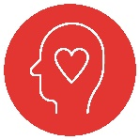A healthier Wales
A more equal Wales
A Wales of more cohesive communities
A Wales of vibrant culture and thriving Welsh language
A globally responsible Wales

Learn and create
We have developed a number of Well-being Objectives to ensure we deliver on our Commitment to Inspire creativity and learning for life.

We’ll work to make sure that:
- We nurture and facilitate creativity for all, and celebrate the creative achievements of Wales.
- All schools in Wales can use Amgueddfa Cymru annually to deliver the national curriculum.
- Adults and families across Wales are inspired to learn with Amgueddfa Cymru.
- Young people lead and produce innovative and creative programmes and experiences.
- Volunteers, placements and apprenticeships are supported to realise their potential.

These support the following Well-being Goals:
A prosperous Wales
A healthier Wales
A more equal Wales
A Wales of more cohesive communities
A Wales of vibrant culture and thriving Welsh language

Put the planet first

We have developed a number of Well-being Objectives to ensure we deliver on our Commitment to Help protect and restore nature and our environment.

We’ll work to make sure that:
- We embed our response to the climate and nature emergency in everything that we do.
- We raise public awareness of the environmental emergency and inspire action.
- Research is focused on biodiversity and environmental change in Wales or of benefit to Wales.
These support the following Well-being Goals:
A prosperous Wales
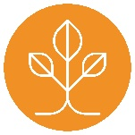A resilient Wales
A healthier Wales
A Wales of vibrant culture and thriving Welsh language
A globally responsible Wales

Support Well-being

We have developed a number of Well-being Objectives to ensure we deliver on our Commitment to Support well-being through inspirational spaces and experiences.

We’ll work to make sure that:
- Our museums will be spaces that support wellbeing.
- People are supported to live healthier and happier lives as part of a well-being programme for Wales.
- We support public enjoyment and well-being through visitor experience to the national museums.

These support the following Well-being Goals:
A resilient Wales
A healthier Wales
A more equal Wales
A Wales of more cohesive communities
A Wales of vibrant culture and thriving Welsh language

Create digital experiences

We have developed a number of Well-being Objectives to ensure we deliver on our Commitment to Discover and explore the museum digitally.

We’ll work to make sure that:
- We improve digital services and infrastructure to grow and enhance digital reach and engagement as an integral part of our user experience and creativity.
- Digital will enhance the physical visit to the national museums creating memorable experiences.
- People can create their own content, experiences, and products by engaging online.

These support the following Well-being Goals:
A prosperous Wales
A more equal Wales
A Wales of more cohesive communities
A Wales of vibrant culture and thriving Welsh language
A globally responsible Wales

Across the world

We have developed a number of Well-being Objectives to ensure we deliver on our Commitment to Build global connections.

We’ll work to make sure that:
- Amgueddfa Cymru will be recognised as a museum of global significance.
- Global partnerships are developed with organisations that share our commitment to social justice, and recognise the value of diversity of indigenous and contemporary knowledge and practice.
- Support the growth of UK and international tourism in Wales.

These support the following Well-being Goals:
A prosperous Wales
A Wales of vibrant culture and thriving Welsh language
A globally responsible Wales

Strategic Enablers

We’ve also developed 9 Strategic Enablers to help us achieve our Commitments and support all the Well-being Goals:

- Sustainability achieved through strong financial governance and management.
- Increase income generation to support delivery of Amgueddfa Cymru 2030 strategy.
- A comprehensive programme of research and evaluation to inform and develop all areas of our work.
- Support and develop our people, trustees, and volunteers to embed trust, respect and inclusion.
- Ensure the people of Wales are part of our decision-making processes.
- The Welsh language is an integral part of all aspects of our work.
- Amgueddfa Cymru will be trusted and recognised by everybody in Wales.
- Our physical infrastructure is fit for purpose.
- Our museums and working practices are safe secure and compliant with Health & Safety and security regulations.

A prosperous Wales
A resilient Wales
A healthier Wales
A more equal Wales
A Wales of more cohesive communities
A globally responsible Wales
A Wales of vibrant culture and thriving Welsh language

Delivery

Delivery against our Commitments, Enablers and Well-being Objectives will be embedded through our usual governance processes via our Planning Framework and achieved through our annual Operational Plans.
These will be monitored against in-year milestones by our Board of Trustees and Welsh Government and reported on quarterly and annually, demonstrating how our work contributes to the Well-being goals and the ways of working.

Further information:

The Well-being of Future Generations | GOV.WALES

Strategy 2030 | Museum Wales

